Functional Design Specifications

**(FDS)**

Implementation of

Energy Components (EC)

Production Modules

For

PNG LNG

15-APR-2013

Version 6.0

# Table of Contents

Functional Design Specifications 1

1 Table of Contents 2

2 Document History 4

3 Summary 5

4 Introduction 5

5 Definition of Terms 5

6 Assumptions 5

7 Out of Scope 6

8 References 6

9 Scope and Limitations 6

10 Unit of Measurement 6

11 Phases to be allocated 6

12 Phases to be calculated 6

13 Phases not to be allocated 7

14 Group Model – Operational 7

15 Group Model – Geographical 8

16 PNG Measurement Model – Rev E 9

17 Production Operations 10

17.1 Safety Health Environment (S.H.E) 10

17.2 Personnel on Location (Board) 11

17.3 Operational Comments 12

17.4 Marine Logistic 13

17.5 Environmental Event 14

17.6 Weather 15

17.7 Equipment Status 16

18 Well and Well Test 17

18.1 Daily Producing Well Status 17

18.2 Daily water injecting (water disposal) Well Status 20

19 Well Testing 22

20 Key Store and Chemical 23

20.1 Chemical Storage status 23

20.2 Chemical Injection 23

21 Streams and Measurement Points 24

21.1 Liquid Stream – Hides facilities 24

21.2 Liquid Stream – LNG Facilities 25

21.3 Liquid Stream – Composition Analysis 26

21.4 Gas Stream 27

21.5 Gas Stream – Composition Analysis 28

21.6 Water Stream 31

21.7 LNG Stream 31

21.8 Volumetric, Mass, and Energy Balance - Equations 33

21.9 Controller’s requirements 34

22 Deferment and Stream Day Capacity (SDC) 41

22.1 SDC 41

22.2 Deferment 41

22.2.1 Master Events – 42

23 Production Planning - Daily 47

23.1 P&B Plan basis 47

23.2 Production Planning – Stewardship requirements 47

23.3 Facility Plan 48

23.4 Daily Production Forecast – For cargo planning 48

24 Well Volumetric Allocation 49

24.1 Well Volumetric Allocation 49

25 Reporting 49

25.1 Internal Reporting 49

25.2 External Reporting 50

26 Interfaces 55

26.1 Input Interfaces - PI 55

26.2 Interfaces – EMDB 55

26.3 Input Interfaces – EDMS 55

27 Appendices 56

27.1 Appendix 1 – Hides equipment list 56

27.2 Appendix 2 – Deferment Types and Names 58

27.3 Appendix 3 – Cause Group & Cause Categories 64

27.4 Appendix 4 – Link to EC Reference mails 66

# Document History

|  |  |  |  |  |
| --- | --- | --- | --- | --- |
| **Action** | **Version** | **Person** | **Organization** | **Date** |
| Created | 1.00 | Tam Vu | ExxonMobil | 29-JUN-12 |
| Updated | 3.0 | Tam Vu | ExxonMobil | 3-DEC-12 |
| Incorporated feedback from Business | 4.0 | Julie Robertson | ExxonMobil | 15-JAN-13 |
| Incorporated feedback from Controller’s workshop | 5.0 | Julie Robertson | ExxonMobil | 13-Feb-13 |
| Incorporated feedback from Business and updated Controllers section | 6.0 | Julie Robertson | ExxonMobil | 15-Apr-13 |
|  |  |  |  |  |
|  |  |  |  |  |
|  |  |  |  |  |
|  |  |  |  |  |

# Summary

This document describes the functional design specification needed to configure the Energy Components (EC) production module for the PNG LNG operation. The PNG LNG organization will review and approve of the contents of this document.

# Introduction

This document will be used by EMIT personnel at ExxonMobil to select and configure the EC objects to fit the PNG LNG production business operations.

An effort is made in this document to make a cross-reference between EHL terminology and EC terminology. In the formula chapter, EHL terminology has been included and may be identified with the symbol, **EHL**.

# Definition of Terms

* Condensate (Hydrocarbons of C5+)
* Non Associated Gas (Hydrocarbon gas produced from a gas reservoir)
* Associated (Assoc) Gas (Hydrocarbon gas produced from an oil reservoir)
* Total Produced Gas
* Total Produced Wet Gas
* Total Produced Condensate
* Total Produced Water
* Total Theoretical Produced Gas
* Total Theoretical Produced Wet Gas
* Total Theoretical Produced Condensate
* Total Theoretical Produced Water
* Naphtha (C5+ hydrocarbon by product from LNG production)

# Assumptions

* Volumetric allocation is described in Volumetric Allocation Specification document.
* Business will provide the following information before this document can be completed.

1. Report specifications
2. Equipment lists
3. Product tanks and storage data
4. Deferment model
5. Chemical tanks and injection point

* PNG reporting is midnight to midnight.

# Out of Scope

* EC Transport, Sales and Revenue modules are being developed as a separated project.
* Potential future expansion wells at Angore, Juha, and P’nyang will need to be included in the allocation at such time as they begin producing.
* Domestic gas sales
* Diesel tracking and balancing specification. (As per Mark Krueger)

# References

* PNG Measurement Model Rev C

# Scope and Limitations

# Unit of Measurement

* Database store data in SI unit
* Report can be in either SI or US Customary unit
* Unit conversion is performed on demand during report generation process.

# Phases to be allocated

* Produced gas, water, and condensate from HGCP back to the gas wells.

# Phases to be calculated

* Gas equivalent of produced condensate.
* Gas equivalent of LNG and Naphtha produced.
* Energy equivalent of LNG and Naphtha produced.
* Mass equivalent of LNG and Naphtha produced

# Phases not to be allocated

* Commercial products (LNG, Naphtha, stabilized crude oil).

Note: Condensate from Hides is mixed with other crude to become crude & condensate (SCO) before loading to tanker to for sale.

# Group Model – Operational

The operational group model is used for screen navigation, reports aggregation, and access control.

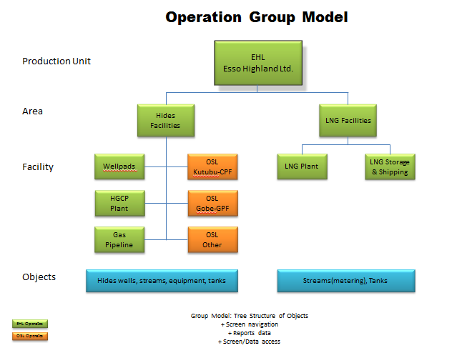

# Group Model – Geographical

The Geographical group model will be used for well allocation, therefore has a different purpose to the Operations Group model.

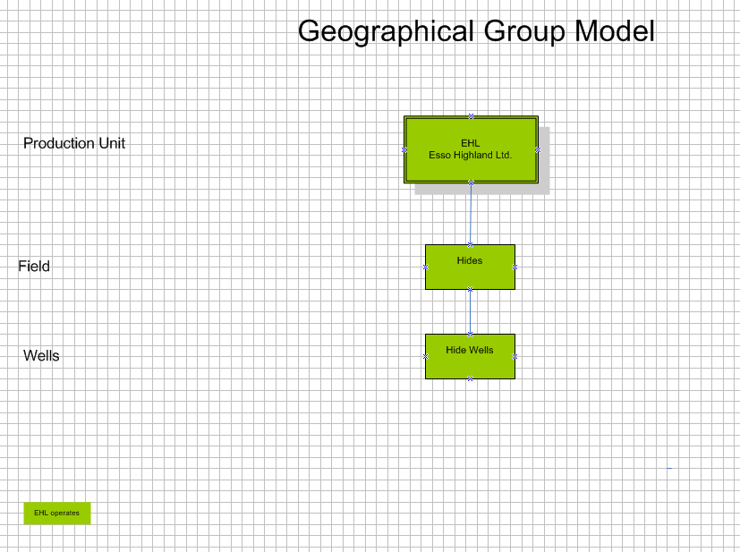

# PNG Measurement Model – Rev E

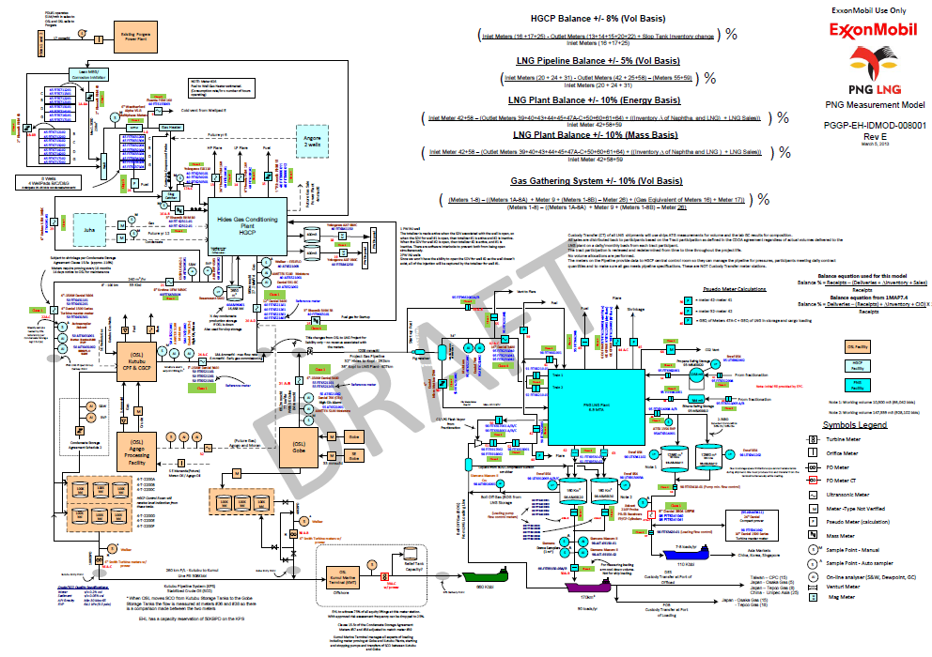

# Production Operations

## Safety Health Environment (S.H.E)

Screen to capture S.H.E. data for morning reports. Primarily manual input by production /control room operator and verified by production supervisor. Other personnel can also input data based on access privileges.

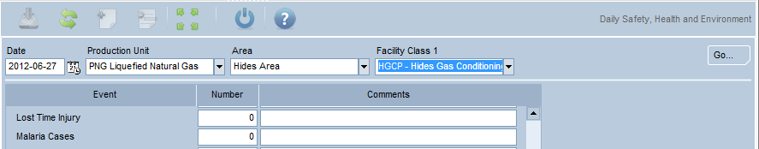

**Events:**

1. Malaria Cases
2. Lost Time Incidents (LTI)
3. Medical Treatment Incidents (MTI)
4. Restricted Work Incidents (RTI)
5. First Aid Treatment Incidents
6. Significant Near Miss Incidents
7. Minor Near Miss Incidents
8. Loss of Primary Containment LOPC
9. Security Incidents
10. Fires/Explosion Incidents
11. Hydrocarbon Gas Release Incidents
12. Hazard/Loss Incidents
13. Chemical Spills/Leaks
14. Hazards identified
15. Positive Observations
16. Hazards Closed Out
17. Near Miss Cards Submitted
18. Loss Prevention Observations (LPOs)
19. Safety Meetings Held
20. Drills/Exercises Held
21. Reportable Process Safety Incidents
22. Business (CIMS) Irregularities
23. Management Walk-Around Inspection
24. Offspec water release to environment if any

## Personnel on Location (Board)

Screen to capture person on location data for morning reports. Primarily manual input by production /control room operator and verified by production supervisor. Other personnel can also input data as well.

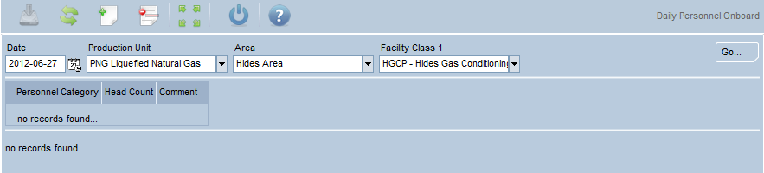

Personnel Category:

* Total Beds
* Operations
* Security
* Camp Staff
* Drilling
* Projects
* Visitors
* Others
* Head Count
* Beds Available
* Comments (Use this to record Personnel at Remote Locations & Valve Stations)

## Operational Comments

Screen to capture comments data for morning reports. Primarily manual input by production /control room operator and verified by production supervisor. Other personnel can also input data as well.

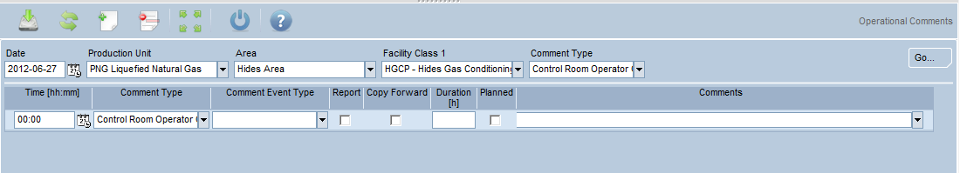

Comment Type: Comment lines available in the daily morning report

|  |
| --- |
|  |
| SHE Comments |
| Control Room Operator Comments |
| Operator Comments |
| Maintenance Comments |
| Construction Comments |
| Logistics Comments |
| Drilling Comments |
| Lifting Specialist Comments |
| Marine Operations Comments |
|  |

## Marine Logistic

Screen to capture tug boat data for marine tug boat report. Primarily manual input by Marine operator/supervisor and verified by production supervisor.

Configure screen as below and produced report in same format.

|  |
| --- |
|  |



## Environmental Event

Screen to capture Environmental event data for morning reports. Primarily manual input by production operator/supervisor and verified by production supervisor. Other can enter data as well such as Marine operator, S.H.E. personnel…

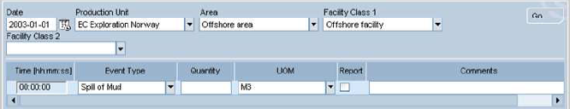

Event Type:

1. Oil Leakage
2. Spill of Mud
3. Gas Leakage
4. Spill of Gas
5. Chemical Spill
6. H2S Release
7. Other environment event
8. Odor Complaint
9. Produced Water Quality
10. Sheen
11. Water
12. Fire
13. Offspec water release to environment if any

|  |
| --- |
|  |
|  |

## Weather

Screen to capture daily weather data for morning reports. Primarily manual input by production operator/supervisor and verified by production. Other can enter data as well such as Marine operator.

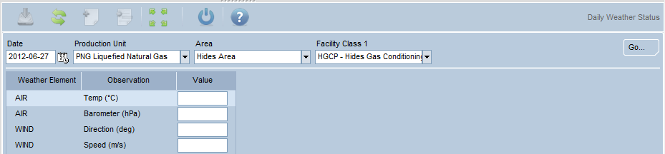

Observation:

* AIR Air Temp (0 degree Celsius)
* AIR Air Barometer (hPa)
* WIND Directing (Deg0
* WIND Speed (m/s)
* PRECI Rainfall (cm)
* WAVES Maximum Height(m)
* WAVES Significant Height (m)
* WAVES Spectral peak Period (s)
* SWELL Direction
* WATER_CURRENT Speed (knots)
* Earthquake intensity

## Equipment Status

Screen to capture daily equipment status data for reporting and deferment. Primarily, on-stream hours are loaded by PI system or manual input by production operator/supervisor and verified by production. Others can enter data as well (such as Marine operator).

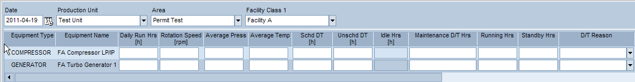

**Hides Equipment List: (Refer Appendix 1)**

# Well and Well Test

## Daily Producing Well Status

Screen displayed producing daily well data including well name, type, producing method, on-stream hours, Choke value, measured injected MEG vol, measured gas vol, measured water vol, measured condensate vol, calculated wet gas vol, allocated wet gas vol, allocated water vol, allocated condensate vol, theoretical wet gas vol, theoretical water vol, theoretical condensate vol, BHT, BHP, WHT, WHP.

Unit of Measurement (UofM) is SI, we can convert to US Customary unit in reports.

MEG volumes shall be subtracted from wellhead produced condensate. We need to take the MEG reading at the well head meter and subtract this from the well head production meters. (Note: Pi will do this calculation)



|  |  |  |  |  |  |  |
| --- | --- | --- | --- | --- | --- | --- |
| **Well Name** |  | **Type** | **Prod Meth** | **On Strm** | **Choke Val** | **Meas Inj MEG** |
|  |  |  |  |  |  |  |
| Well 1 |  | Gas Producer | Flowing | 24 | 100 |  |
| Well 2 |  |  |  |  |  |  |

|  |  |  |  |  |  |  |
| --- | --- | --- | --- | --- | --- | --- |
| **Meas Prod Gas** | **Meas Prod Wtr** | **Meas Prod Cond** | **Calc Dry Gas** | **Alloc Prod Wet Gas** | **Alloc Prod Wtr** | **Alloc Prod Cond** |
|  |  |  |  |  |  |  |
|  |  |  |  |  |  |  |
|  |  |  |  |  |  |  |

|  |  |  |  |  |  |  |
| --- | --- | --- | --- | --- | --- | --- |
| **Theor Dry gas** | **Theor Wtr** | **Theor Cond** | **WHT** | **WHP** | **BHT** | **BHP** |
|  |  |  |  |  |  |  |
|  |  |  |  |  |  |  |
|  |  |  |  |  |  |  |

Theoretical is the measured volume at each well head meter. If the meter does not work, the well test volume will not be used. The allocated volume will be used. The last Gross volume at the same choke setting shall be used for this allocation.

Sample of current well test Kubutu maintains. Similar for PNG-LNG project also.

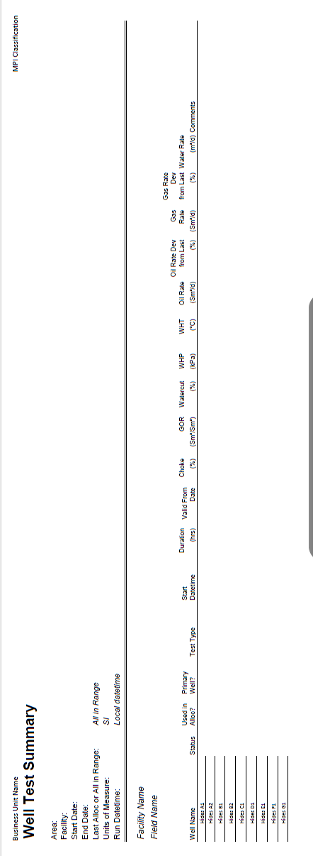

## Daily water injecting (water disposal) Well Status

Screen displayed injecting daily well data including well name, type, on-stream hours, Choke value, measured injected water vol, allocated water vol, theoretical water vol, BHT, BHP, WHT, WHP.

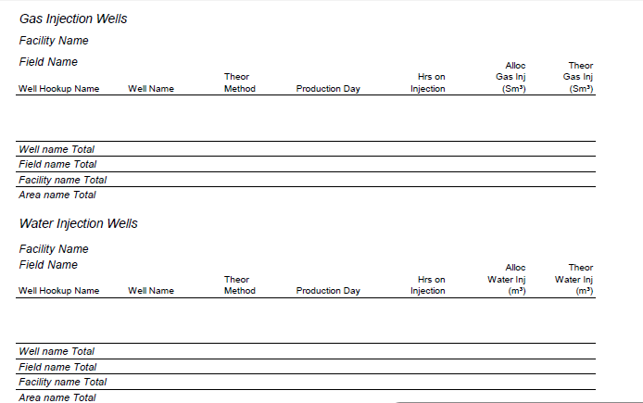

Remove Gas Injection Wells section from the report below.

Sample monthly production and injection report –

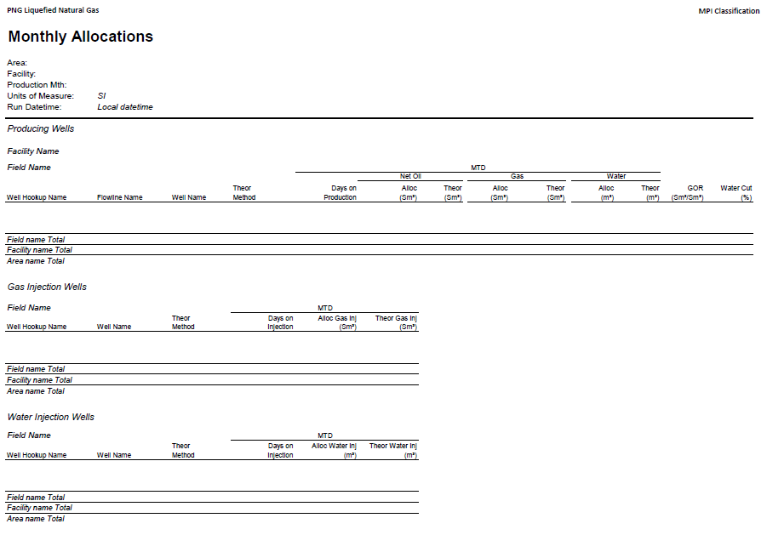

# Well Testing

There is no test separator at Hides, but EHL is obligated to produce periodic well test data to PNG government. PI team will build a well test screen to enable production operator to determine a stable period for each well to capture data from the well head multiphase meter as well test data at various choke settings. This well test data should consist of well name, beginning period, ending period, choke size, water vol, liquid vol, dry gas vol, temperature, pressure etc

**CONDENSATE VOL = LIQUID VOL – MEG INJECTED VOL**

# Key Store and Chemical

## Chemical Storage status

Screen to capture key store (examples include chemical, diesel, drinking water…) daily inventory for each tank. Opening volume is the previous day closing volume. Closing and Filled volume can be either transferred from PI or manual input.

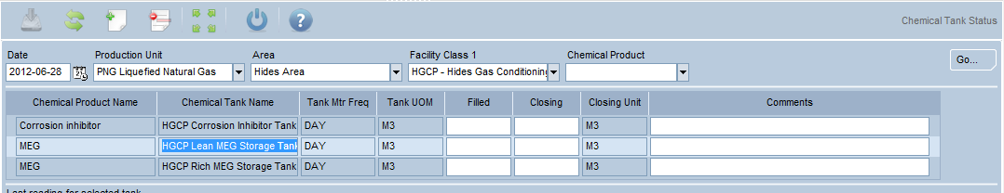

Diesel balancing will be managed out of EC. EC will track two main diesel tanks (one at LNG plant and one at HGCP) and report them as part of the Key Store as part of morning report.

MEG storage inventory change and deliveries to be captured here.

## Chemical Injection

Screen can be display and capture key store (including chemical, diesel, drinking water…) daily injection by facility, chemical product and asset (injecting point). Three main volumes and UofM: measured, calculated and recommended.

MEG use and inj volumes to be captured here.

# Streams and Measurement Points

## Liquid Stream – Hides facilities

Screen can be display and capture condensate streams. Measured streams represent measured point such as meter reading. Derived and Calculated streams represent EC specified calculated figures such as total produced condensate. This total condensate is allocated to each well.

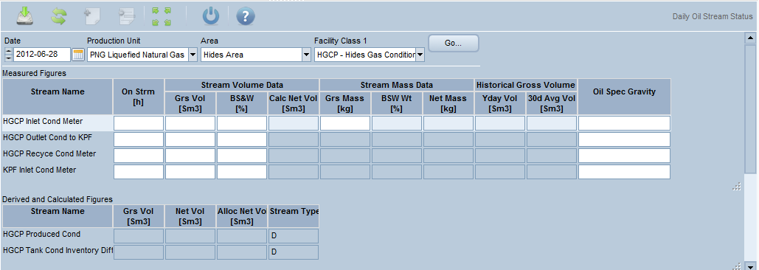

Measure Streams - Hides:

* HGCP Outlet Cond to CPF (21)
* HGCP Recycle Cond Meter (23)
* CPF Inlet Cond Meter (22 A-C)

Derived Streams - Hides:

* HGCP Produced Cond
* HGCP Tank Cond Inventory Diff

## Liquid Stream – LNG Facilities

Screen to display and capture liquid hydrocarbon streams. Measured streams represent measured point such as meter reading. Derived and Calculated streams represent EC specified calculated figures such as total produced condensate.

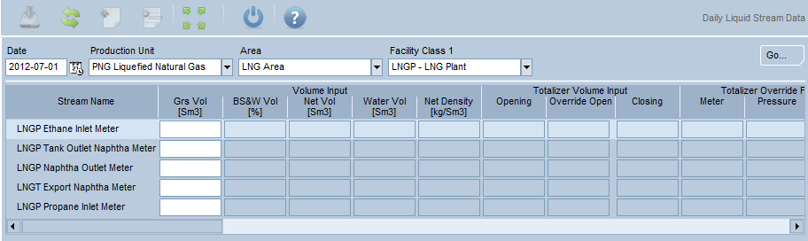

Fields required are:

* Grs Vol (Sm3)
* BS&W Vol (%)
* Net Vol (Sm3)
* Water Vol (Sm3)

Measure Streams – LNG Plant:

* MR Make-up – Ethane (60)
* MR Make-up – Propane (61)
* LNGP Tank (56)
* Naphtha Tank
* LNGP Export Naphtha Meter (47 A-C)

For Naphtha we measure the tank volume every day and we measure what we load into the ship through the meter. Change in tank inventory and loaded volume will represent the Naphtha production of the day.

## Liquid Stream – Composition Analysis

Stream Composition Analysis screen is used to collect and store Naphtha and SCO (stabilized crude oil) composition. Naphtha data is from EHL lab --> LIMS --> PI --> EC. SCO composition lab data is expected to be from OSL (Oil Search Limited) report then entered into LIMS manually to store in PI database.

This data is used in Transport for reporting along cargo document.

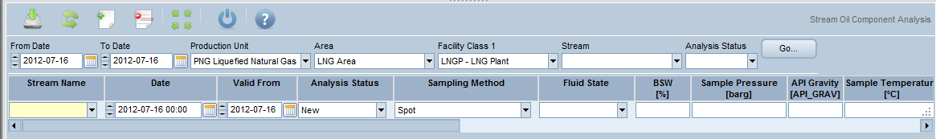



Configure screen and data object to include lab data as required per EC-TSR specification.

Include one screen for Analyzer data from HGCP and LNGP.

Oil – condensate & Naphtha (HGCP, LNGP)

LNG – LNGP facility

## Gas Stream

Screen can be display and capture gas streams. Measured streams represent measured point such as meter reading. Derived and Calculated streams represent EC specified calculated figures such as total produced gas.

Add a monthly stream to capture SE Gobe purchased gas and also have a derived stream which will be Gobe Export Gas meter (31 A-B) – SE Gobe Purchased gas

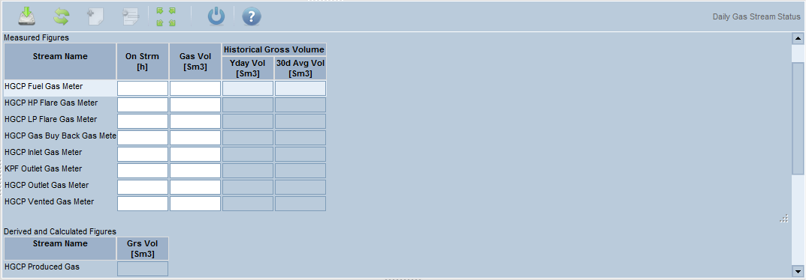

Measure Streams - Hides:

* HGCP Fuel Gas Meter (15)
* HGCP HP Flare Gas Meter (13)
* HGCP LP Flare Gas Meter (14)
* HGCP Start up Gas Meter (25)
* HGCP Inlet Gas Meter (17 A-C)
* CPF Export Gas Meter (24 A-C)
* HGCP Export Gas Meter (20 A-D)
* HGCP Well Heater Gas (26)
* Gobe Export Gas Meter (31 A-B)

Derived Streams - Hides:

* HGCP Wells Produced Gas

Measure Streams – LNG Plant:

* LNGP Startup Fuel Meter (59 A-B)
* LNGP Vented to Flare Gas Meter (55)
* LNGP Fuel Gas Meter (43)
* LNGP Flare Gas Meter (44 A-C)
* LNGP Inlet Gas Meter (42 A-C)

Derived Streams – LNG Plant:

* LNGP Shrinkage (45)
* LNGP Boil Off Gas to Fuel (39)
* LNGP Boil Off Gas to Flare (40)

Derived Stream 39 = Meter 42 – Meter 41

Derived Stream 40 = Meter 52 – Meter 42

Derived Stream 45 = GEQ of Meter 47 A-C + GEQ of LNG in storage and cargo loading

## Gas Stream – Composition Analysis

Gas stream composition analysis is data from on-line GC’s and Lab analysis. PI collects both data and transfers to EC.

Add Moisture Analyzer and Wobbie Index if they don’t already exist

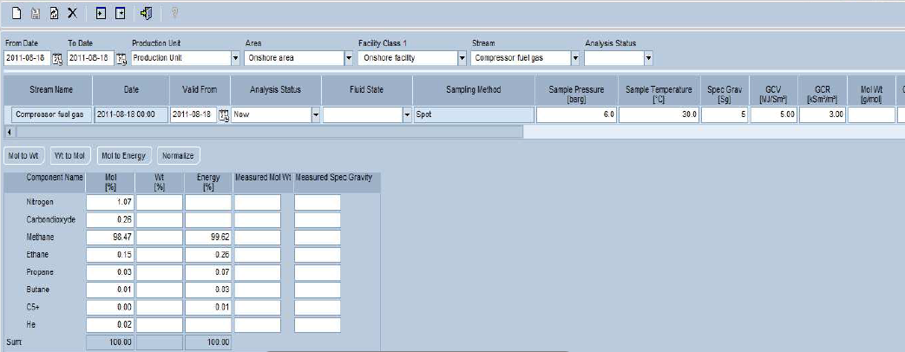

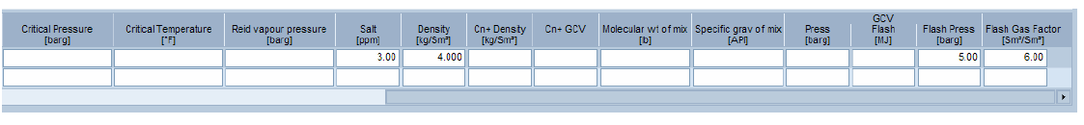

Will collect the following component Mol% for LNG energy calculation:

1. Methane(CH4),
2. Ethane (C2H6),
3. Propane (C3H8),
4. iso-Butane (i-C4H10),
5. Normal Butane(n-C4H10),
6. iso-Pentane(i-C5H12),
7. Normal-Pentane(n-C5H12),
8. Hexane (C6H14),
9. Heptane (C7)
10. Octane (C8)
11. Nonane +(C9+)
12. Nitrogen(N2),
13. Carbon Dioxide(CO2),
14. Oxygen (O2).

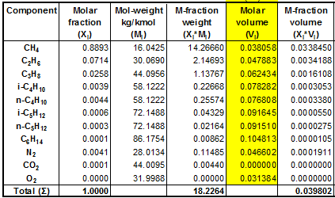

## Water Stream

Screen will capture and display water streams. Measured streams represent measured point such as meter reading. Derived and Calculated streams represent EC specified calculated figures such as total produced water.

Historical gross volumes below may be required.

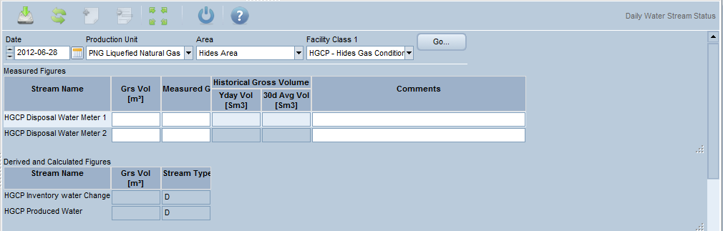

Measure Streams - Hides:

* HGCP Disposal Water Meter 1 (18)
* HGCP Disposal Water Meter 2 (19)

Derived Streams - Hides:

* HGCP Inventory Water Change
* HGCP Produced Water
* HGCP Water Sent to CPF

## LNG Stream

Screen can be either display and capture LNG streams. Measured streams represent measured point such as meter reading. Derived and Calculated streams represent EC specified calculated figures such as total produced LNG.

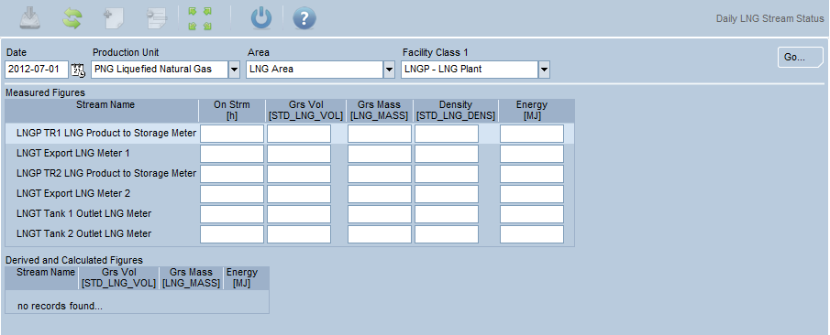

Measure Streams – LNG Plant:

* LNGP TR1 LNG Product to Storage Meter (62)
* LNGP TR2 LNG Product to Storage Meter (63)
* LNGP Tank 1 Outlet LNG Meter (48 A-E)
* LNGP Tank 2 Outlet LNG Meter (49 A-E)

## Volumetric, Mass, and Energy Balance - Equations

EC calculates the following volumetric balances: HGCP Balance, LNG Pipeline Balance, LNG Plant Balance (energy & Mass-tonnes), Gas Gathering System Balance. Result is printed on morning report Executive (MRE).

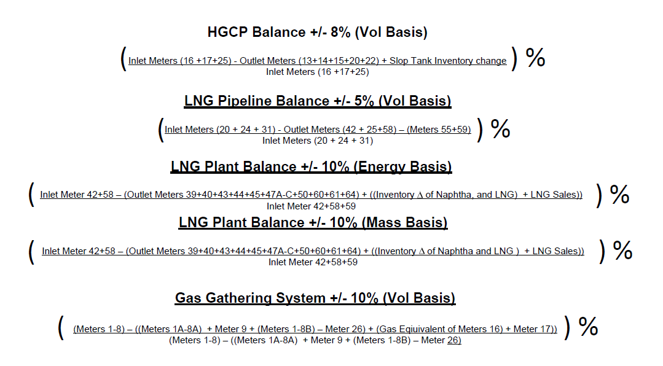

MEG Balance equations – To be determined

Note:

* Meter numbers are based on PNG Measurement Model Rev E

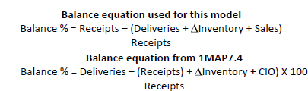

## Controller’s requirements

**UXM Conform 2020 – Volumes Inputs for Liquids**

|  |  |  |
| --- | --- | --- |
| **UXM**  **CF 2020 Line** | **Description** | **Source** |
| 60-90 | Net production   1. NWI share of crude oil and condensate. 2. Excludes royalties, purchases and quantities due others. 3. Includes C&C consumed, flared, lost or otherwise used in production operations. 4. Stated in barrels at 60⁰F and corrected for water content. 5. Correct for MEG injected volumes? | Liquids:   1. (Gross liquids production (see L 105) x GWI) less Royalty (Royalty calculation TBD per (2) below) 2. Reservoir/ Controller’s to determine whether to use effective royalty, stated 2%, or no volume impact (deemed a prepayment of income taxes). Implementation will assume that Houston will approve proposal for zero royalty (all as prepaid taxes). 3. EC standard functionality to capture fuel and flare volumes 4. EC team/ Measurement confirmed liquids stated at standard conditions consistent with corporate reporting requirements 5. No adjustment required. EC already subtracts MEG volumes. The liquids meter is recording both hydrocarbons and MEG injection volumes. However, since the MEG injection is metered separately, EC will subtract the injected volumes from the hydrocarbon meter reading at the wellhead meters. |
| 105 | Gross EM Operated Production  100% gross basis before deductions for royalty, etc. | Liquids:  Inlet meter to Kutubu system # 22A-C (Condensate) adjusted for water content. MEG is recovered and recycled at the Hides separation facility so no MEG adjustment needed at these meters.  +LNG Plant # 47A-C for naphtha (sales volumes)  +/- change in Naphtha inventory (98-ABJ63411, 98-ABJ63412; has ATG). ATG usually only provides change in tank level.  +/- change in slop oil tank at HGCP (40ABJ9641)  - Purchased Naphtha (SE Gobe). To be determined using C5+ composition from manual sample lab report (captured at least 1x/year or when a new field comes in) multiplied by actual throughput from each inlet meter. Naphtha sales will be allocated on basis of relative theoreticals. Team feels this is cost effective approach relative to materiality.  - Assumes that Associated Gas volumes (gas and naphtha) that are part of the LNG Project are considered EMOP production (even though supplied by OSL). |
| 110 | Net Sales  EMNI volumes delivered to 3rd parties and affiliated companies, including overlift. Excludes royalties and any volumes purchased, used in operations or put into storage. | + GWI sales per BOL or shipping docs at Kutubu terminal x EM share  + GWI sales per Naphtha BOL or shipping docs x EM share  - Royalty impact (assuming zero)  - GWI share of purchased “naphtha” volume (TBC)  Note: Naphtha sales volumes are allocated based on GWI among all participants (no need to allocate purchased volumes) |

**UXM Conform 2020 – Volumes Inputs for Gas**

|  |  |  |
| --- | --- | --- |
| **UXM**  **CF 2020 Line** | **Description** | **Source** |
| 60-90 | Net production   * Conceptually represents EMNI quantities withdrawn from reservoirs. Excludes royalties, purchases, reinjected volumes, condy or NGL shrinkage and volumes due others. * Reported in cubic feet at 60⁰F and 14.73 psig; corrected for water and inerts. Also need GBTU. * Includes gas consumed per L 102 | * Pressure needs to be adjusted to 14.73 per corporate standard ; flow computer capturing at 14.696 per CDOA * (Gross production x GWI) – royalty (effective rate or stated 2% of sales TBD) * Corrected for water, nitrogen, CO2, etc. since not included in reserves determination. See line 105. |
| 102 | Gas Consumed and Flared   * Gas Consumed and Flared * Gas consumed, flared or otherwise used in production operations AND included in Proved Reserves. * Need to split among:   + Gas lost, vented or flared   + Consumed as lease fuel   + Consumed as gas plant fuel * Excludes LNG plant fuel (TBC) * Any fuel associated with fibre optic system? | **Hides:**  + Hides meters # 13-15 for fuel and flare (use #15 for fuel valuation)  + Calculated volume (#26) used for line heater fuel (valued)  + Vented gas (# 9)  **LNG Plant:**  + Flare: #’s 40, 44 A-C, 55  + Fuel: #’s 39, 43  + Refrigerant (C2, C3 components) Use inlet meters 60 and 61 into tanks. NOTE: Tanks (one for ethane, one for propane) will be restocked several times/year from plant production after initial stock by EMDC. Maximum tank capacity is 2268 m3 of propane and 384 m3 of ethane. A more precise process would be to track tank inlets as product inventory and tank outlets as plant use for the cooling system. According to Darrell, even the restocking volumes are so small compared to the full plant consumption that they should not result in spikes in fuel costs in the months when the tanks are replenished.  **Terminal and Vessels:**  + Purge & cool (BOG) captured in Transport module *(may be invoiced)*  + Transport BOG (Boil Off Gas)  + Excess BOG due to Buyer delays *(may be invoiced)*  + Forced BOG for powering vessels *(valued at LNG sales $)*  FU: Production plans to convert diesel generators to fuel. Need to ensure MOC picks up increase to fuel volumes for corp. rptg. |
| 105 | Gross EM Operated Production  100% gross basis before deductions for royalty, etc. | + Hides meters 13-15 for fuel and flare  + Calculated volume used for line heater fuel (# 26)  + Vented gas (#9)  + Meter 20 A-D Hides outlet into PL  + Associated gas inlet Meters # 24 A-C, 31A,31B (assuming OSL production is considered EMOP).  - LESS theoretical naphtha embedded in gas streams, per calculation for SE Gobe (theoretical C5+). Will obtain periodic composition analyses for each gas stream to determine theoretical C5+ composition. Will convert C5+ to gas equivalent volumes so can subtract from metered gas.  Pressure needs to be adjusted to 14.73.  Metered volumes include CO2 and Nitrogen. May need to back out the inerts. (TBC) Will use compositional analysis for this adjustment also. Applied to all Hides meters. |
| 110 | Net Sales   * EMNI volumes delivered to 3rd parties and affiliated companies reported on an “entitlements” basis. * Includes actual gas delivered to LNG plant * Excludes royalties and any volumes purchased, used in operations or put into storage. | + LNG sales volumes need to be available in both KCF and MBTU  + Will need to back out royalties (assumed to be zero) and LNG sales associated with SE Gobe gas purchase  + UFC (Malcolm Ogg) has confirmed that volumes used by the plant will be reported as a sale |
| 140 | Gas Purchases From 3rd Parties   * Excludes purchases from EM royalty owners * For LNG, may include difference between gas delivered to plant (L 110) and export market volumes * Excludes volumes purchased for use in production operations such as fuel, injection, etc. | + SE Gobe gas purchase, net of attributed naphtha volumes |
| 141 | Interregional LNG Sales and Purchases from Affiliates  Excluded from L 155 and L 170  Volumes between affiliates must balance |  |
| 145 | Gas Purchases from EM Royalty Owners  Reflects volumes associated with cash royalties | Assumed to be zero. |
| 146 | Gas Production Over/Shorts | N/A since LNG is sold as common stream |
| 147 | Gas Inventory Draw/(Build)  Used to represent increase/decrease of LNG volumes in transit to sales point | * ATG available for both tanks; volumes in EC * Convert m3 measured to KCF and GBTU * Discuss with UFC – should also reflect changes in LNG tank inventories |
| 149 | Gas/LNG Consumed in LNG Activities   * Represents gain/(loss) during liquefaction, transportation or the regassification process. * Would include normal boil-off, excess boil-off, purge & cool losses, etc. * LNG plant fuel? (TBC) | * See L 102 and 110 |

Monthly streams required to capture data received from OSL (Bbls):

1. LNG Plant condensate corrected production – manual input
2. LNG Plant condensate production adjusted for shrinkage – EC calculated (Controllers to provide contract shrinkage percentage, refer Condensate Storage Agreement clause 15.5a)
   * Calc: Sum of daily CPF Inlet Cond Meter (22A-C) adjusted for contract shrinkage percentage
3. LNG Plant condensate production quality bank adjustment – EC calculated (1-2)
   * To be used for YE recon of production vs sales
4. OBO oil fields gross production – manual input
5. OBO oil fields corrected production – manual input

Other monthly streams:

1. Purchased gas component of Gobe associated gas deliveries

# Deferment and Stream Day Capacity (SDC)

## SDC

Single Stream day capacity defined at inlet to LNG Plant as PNG is facility constrained.

Condensate SDC not required as condensate production is directly correlated to LNG production.

## Deferment

EM standard is to utilize the Well and Equipment functionality of EC 10.X to report deferment. Products subject to deferment are Wet Gas & Condensate (condensate TBC), for Hides facility and LNG Plant.

Equipment and Well Deferment consists of Master Events, Well Downtime, Equipment Downtime, and Well Constraints.

Equipment downtime will only be for volumetric loss events.

Well downtime will include non-volumetric events as wells can be offline without impacting production as PNG is not well constrained; production is restricted by Plant capacity.

Deferment includes Idle economic planned, unplanned and Idle uneconomic consistent with existing corporate standards/reporting

### Master Events –

Master Events are associated with incidents that may be caused by human, mechanical or natural causes. They may be assigned to other object events such as,

* Well downtime.
* Well constraints
* Equipment downtime
* Environmental events

For example, if you had a hurricane pass through a facility, you would record the Master Event as the Hurricane and would identify when it happened where and perhaps other comments. Then you would create and associate with that Master Event other well and equipment events and perhaps environment events, if there was a release of hydrocarbons.

A Master Event is given a unique ID, visible to the user that is made up of a 5 digit code plus year, month and day, plus a sequence number. It is system generated.

Current Master events are:

* Compressor
* Electrical
* Hurricane
* Natural Disaster
* Transfer Line Leak

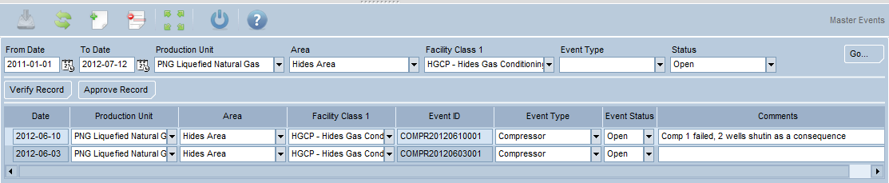

**Well Downtime –**

Well downtime is recorded when a well is active, but is shut-in for a period of time. Such events include well work-overs and equipment failures, external events and acts of nature that force one or more wells to be shut in.

Single and group well downtime events must be recorded and assigned the appropriate reason codes. When a group well downtime event is recorded, individual wells may be added to a group one at a time, or many at a time.

Deferred volumes must be associated with the downtime event to ensure proper reporting of the volumetric impact of such downtime.

If there is no volumetric loss associated with the well being shut-in, then the event will be recorded with a zero volume loss. (required to over write well potential).

The Start and End date/times of downtime events are used to calculate daily downtime hours and daily deferred volumes. Daily downtime volumes and hours may be used in calculating well theoretical volumes. Well downtime information is useful in improving reliability and reporting Key Performance Indicators (KPIs).

Overlapping events are not allowed in the well downtime business function. However, overlap is allowed between the well downtime and well constraint events.

. 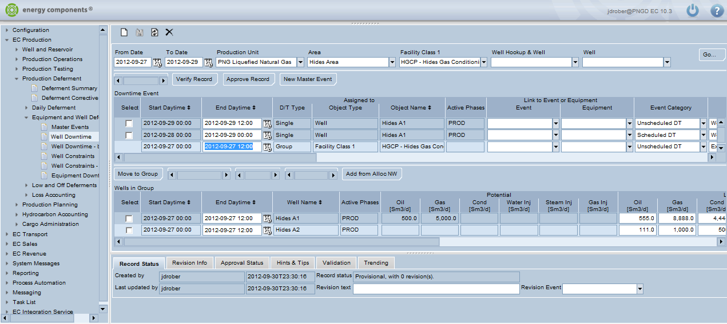

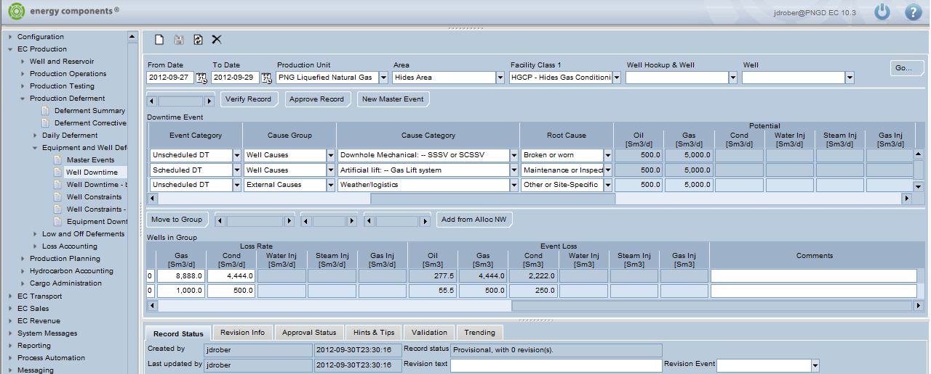

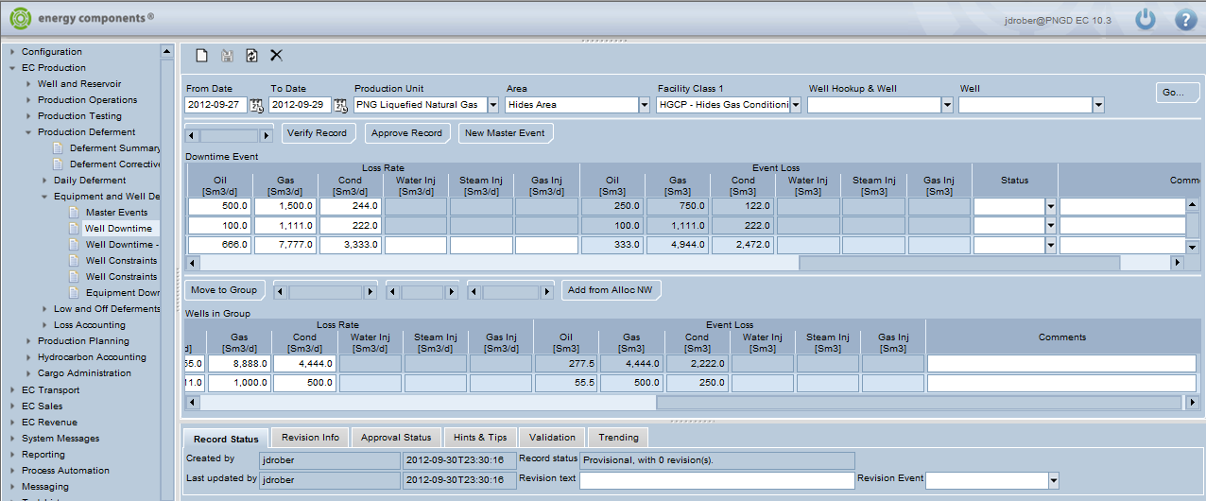

When equipment failures cause wells to be shut-in, then it is important to associate the equipment and well downtime (sometimes more than one piece of equipment is involved in the same incident). A Master Event may be associated with well and equipment downtime to tie everything all together. A Master Event may be associated with either a single or group well downtime event. This is critical if reports are to tie together all downtime events associated with the Master Event, for example:

* Well downtime (well shut-in)
* Well constraints (well flowing, but with constrained production)
* Equipment downtime
* Environmental events (such as a release of hydrocarbons)

**Well Constraints –**

Well constraints is recorded when a well is active, but with constrained production.

Overlapping events are allowed in the well constraints business function and also is allowed between the well downtime and well constraint events.

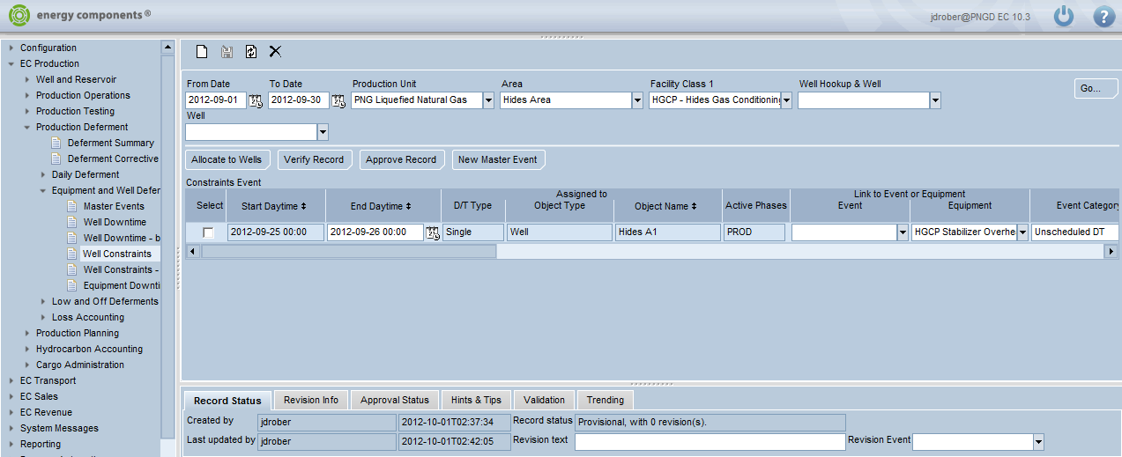

**Equipment Downtime**

When equipment in a facility is shut down, an entry must be made to indicate when and why. This information is useful in improving reliability and reporting Key Performance Indicators (KPIs). When such equipment downtime causes wells to be shut-in, then it is important to associate the equipment and well downtime. Sometimes more than one piece of equipment is involved in the same incident, and the individual pieces of equipment are connected with a group equipment downtime event.

This Equipment Downtime business function is used to record all such situations.

Single equipment downtime events may be recorded A group equipment downtime event may be recorded, and several pieces of equipment attached to the group Start date and time and end date and time are recorded for both single and group equipment downtime events, along with reason codes that may be configured for each implementation. In addition, and importantly, a Master Event may be associated with either a single or group equipment downtime event. This is critical if reports are to tie together all downtime events associated with the Master Event:

Well downtime (well shut-in)

Well constraints (well flowing, but with constrained production)

Equipment downtime

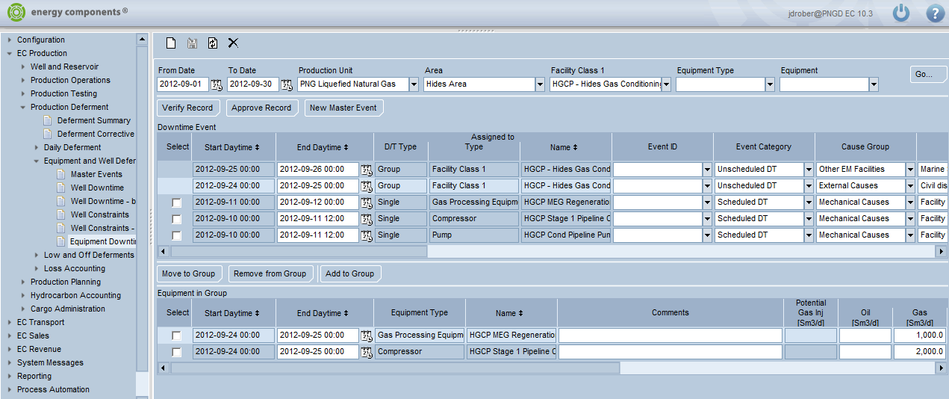

‘Type’ on EC screen to be renamed to ‘Facility / Plant System’

‘Name’ on EC screen to be renamed to ‘Code Equipment / Component’

**Refer Appendix 2 for Deferment Types and Names**

**Refer Appendix 3 for Deferment Cause Groups & Cause Categories**

# Production Planning - Daily

Production planning for Dry Gas, Condensate, LNG (TBD), Naphtha (TBD). Production planning by facility, well (TBD), field (TBD). There are four different plans: Budget, Potential, and Target.

## P&B Plan basis

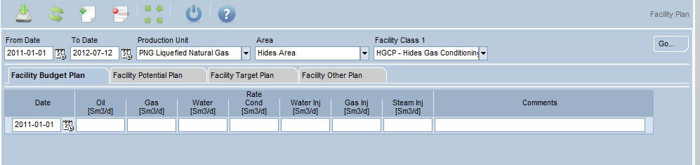

## Production Planning – Stewardship requirements

Production forecasting for Dry gas, LNG, Condensate, Naphtha and Fuel & Flare will be required for stewardship reporting (P&B/MYU).

In addition the P&B/MYU capacity will also be recorded.

Production & capacity planning will be for the following facilities:

* Upstream Area > HGCP - Hides Gas Conditioning Plant
  + Dry gas & Condensate
* Downstream > LNGP – LNG Plant
  + LNG, Condensate & Naphtha, F&F

There are four different plans available in EC: Budget, Potential, Target and Other (refer screen shot below). These tabs will be renamed based on info below - to be confirmed by the business exact description for the name.

* Facility Budget Plan will be used for the P&B Production forecast
* Facility Potential plan will be used for the Production forecast Mid-Year Update (MYU).
* Facility Target plan will be used for the P&B capacity.
* Facility Other Plan will be used for the capacity MYU.

P&B and MYU Dry gas production data can also be captured by well under Plan > Well Plan if required.

This data will be captured by month and will be entered into EC via excel upload spreadsheet.

Oil, Gas inj, and Steam inj will not be required.

## Facility Plan



## Daily Production Forecast – For cargo planning

Production forecasts will be provided by EMPC for cargo planning purposes and will be used in the ADP (Annual delivery Plan) and 90 day schedules. These forecasts will be uploaded via an excel spreadsheet into Daily Storage Forecast in the Transport module and will be covered in more detail in the Transport FDS.

**Daily production forecasts are required for the following Products:**

* LNG production
* Condensate production – best case only
* Naphtha production – best case only

**LNG will have 3 forecasts:**

* Best Case
* High Side
* Low Side

# Well Volumetric Allocation

## Well Volumetric Allocation

Refer separate document

# Reporting

## Internal Reporting

Below are the list of preliminary identified reports and potential reports. Jasper is the software used to developed reports. Result can be saved in different format including PDF, Excel.

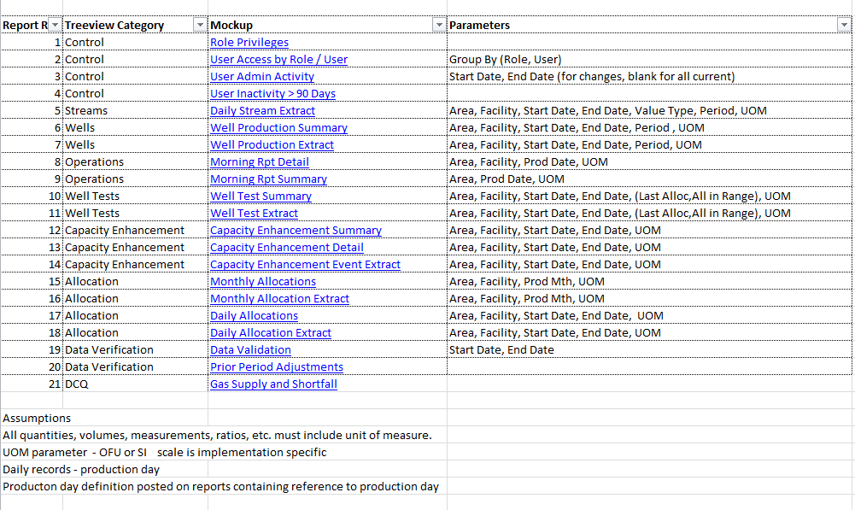

## External Reporting

Below are the list of preliminary identified reports and potential reports. Jasper is the software used to developed reports. Result can be saved in different format including PDF, Excel.

1. Well Test Report
2. Flare Report
3. Daily Production Report
4. Monthly Production Report
5. Gas Supply and Shortfall - DCQ

Sample:

Well Test Report:

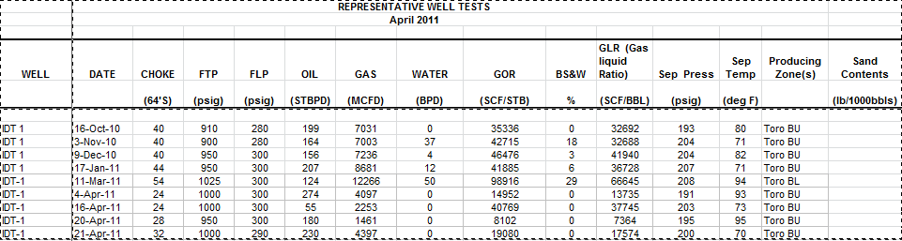

Flare Report in EC:

EDMS will get all of its metering and composition data from production.

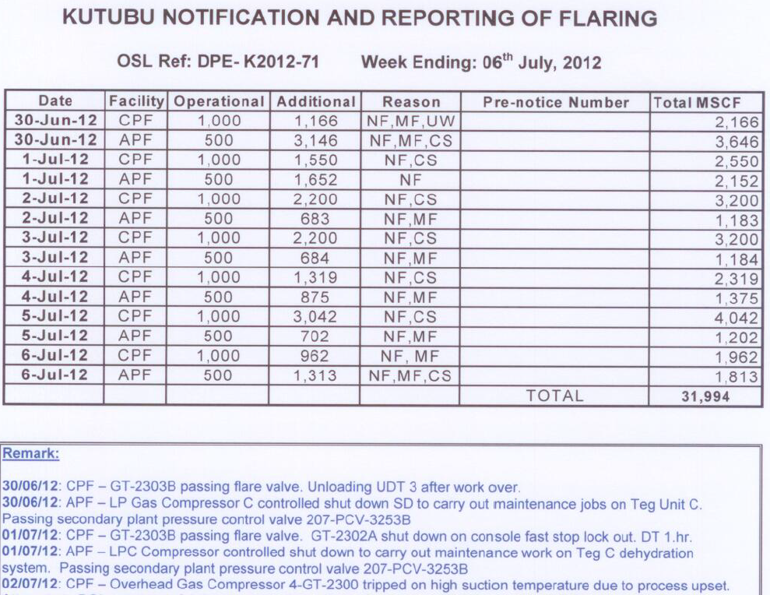

Production Report: Monthly 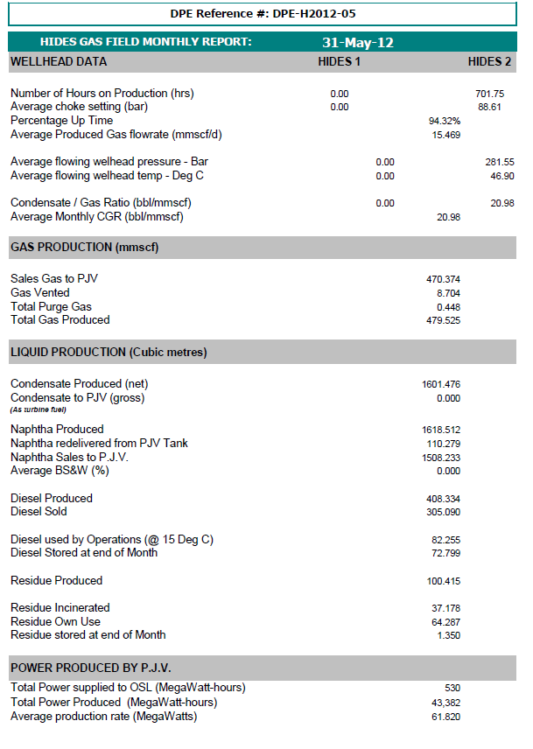

Production Report: Gas Supply and Shortfall - DCQ



Production Report: Daily 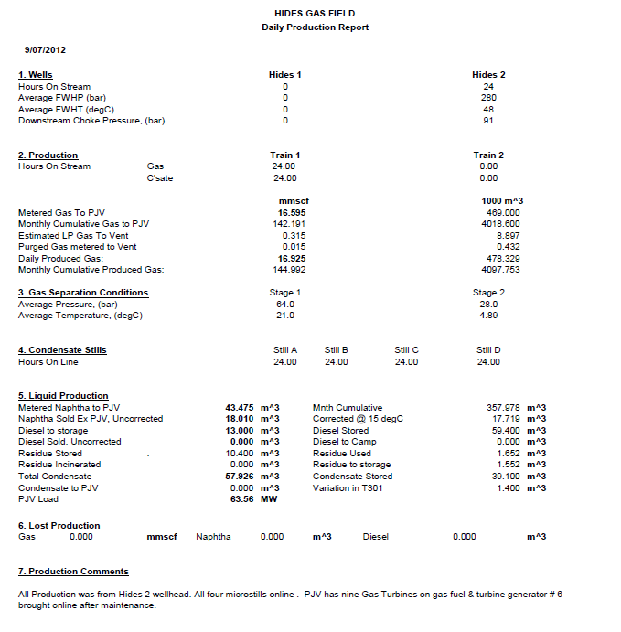

# Interfaces

## Input Interfaces - PI

EC team to provide PI list of required tags to configure and load into the PI concentrator including:

* Meters volume, mass, compositions, temp, pressure
* Tank closing volume, mass.
* Chemical tank closing volume, filled volume, injected volume.
* Well’s on-stream hours, WHP, WHT, BHP, BHT, measured volumes (Liquid, gas, water)
* Equipment’s on-stream hours
* Well test. PI builds screen for operator to determine a stable period and collect data from the multiphase meters as well test and passes to EC.
* Lab data. Lab data came from LIMS ---> PI ----> EC.

## Interfaces – EMDB

As currently known, there is a new project going on EC/EMDB interface and will provide EC EMIT project team the list of required tables. EC team will develop the database view same as the table. EMSDB will have a read-only Oracle account in EC database to extract data from EC.

## Input Interfaces – EDMS

All data coming into EC manually. Any data required by EDMS will be captured from EC screens by respective personnel.

# Appendices

## Appendix 1 – Hides equipment list

|  |  |
| --- | --- |
| **Equipment Name** | **Equip. Tag** |
| Essential Generator “A” | **VTDE83710** |
| Essential Generator “B” | **VTDE83720** |
| Generator “A” | **VTPGT83310** |
| Generator “B” | **VTPGT83320** |
| Generator “C” | **VTPGT83330** |
| Instrument Air Compressor “A” | **VCIA95510** |
| Instrument Air Compressor “B” | **VCIA95520** |
| Instrument Air Compressor “C” | **VCIA95530** |
| Firewater Jockey Pump | **PJK41101** |
| Electric Firewater Pump | **PFW41102** |
| Diesel Firewater Pump | **PFW41103** |
| Potable Water Treatment Package | **VABM97710** |
| De-mineralized Water Treatment Package | **VABM97711** |
| Potable Water Pump “A” | **PPW97721** |
| Potable Water Pump “B” | **PPW97722** |
| Utility Water Pump “A” | **PBE97801** |
| Utility Water Pump “B” | **PBE97802** |
| HP Flare KO Drum Pump “A” | **PBA61211** |
| HP Flare KO Drum Pump “B” | **PBA61212** |
| Closed Drain/LP Flare Drum Pump “A” | **PBA99111** |
| Closed Drain/LP Flare Drum Pump “B” | **PBA99112** |
| Liquids Inlet Separator #1 | **MBD62311** |
| Liquids Inlet Separator #2 | **MBD62312** |
| Stabiliser Feed Surge Drum | **MBD62601** |
| Gas Inlet Separator # 1 | **MBD62301** |
| Gas Inlet Separator # 2 | **MBD62302** |
| Gas Inlet Separator # 3 | **MBD62303** |
| Stabiliser #1 Column | **NST62610** |
| Stabiliser #1Reboiler | **HBC62610** |
| Stabiliser #1 Reflux Accumulator | **MBD62610** |
| Stabiliser #1 Reflux Pump “A” | **PBA62611** |
| Stabiliser #1 Reflux Pump “B” | **PBA62612** |
| Stabiliser #2 Column | **NST62620** |
| Stabiliser #2 Reboiler | **HBC62620** |
| Stabiliser #2 Reflux Accumulator | **MBD62620** |
| Stabiliser #2 Reflux Pump “A” | **PBA62621** |
| Stabiliser #2 Reflux Pump “B” | **PBA62622** |
| Stabiliser Overhead KO Vessel | **MBD62630** |
| Stabiliser Overhead Compressor #1 | **VCBA62640** |
| Stabiliser Overhead Compressor #2 | **VCBA62650** |
| Condensate Pipeline Pump “A” | **PAX64301** |
| Condensate Pipeline Pump “B” | **PAX64302** |
| Condensate Pipeline Pump “C” | **PAX64303** |
| Pipeline Compressor Turbine # 1 | **CGT65110** |
| Pipeline Compressor # 1 Stage One | **CBA65111** |
| Pipeline Compressor # 1 Stage Two | **CBA65112** |
| Pipeline Compressor Turbine # 2 | **CGT65120** |
| Pipeline Compressor # 2 Stage One | **CBA65121** |
| Pipeline Compressor # 2 Stage Two | **CBA65122** |
| Pipeline Compressor Turbine # 3 | **CGT65130** |
| Pipeline Compressor # 3 Stage One | **CBA65131** |
| Pipeline Compressor # 3 Stage Two | **CBA65132** |
| DRA Injection Skid | **VPBE67701** |
| DPCU Heater | **HBG66341** |
| Meg Vent Gas KO Drum | **MAM66710** |
| Meg Vent Gas Incinerator | **VEAL66710** |
| Meg Regenerator Package “A” | **VNBA67120** |
| Meg Regenerator Package “B” | **VNBA67130** |
| Meg Transfer Pump | **PBE67140** |
| HGCU Meg Injection Pump “A” | **PBE67141** |
| HGCU Meg Injection Pump “B” | **PBE67142** |
| Wellpad Meg Injection Pump “A” | **PBE67143** |
| Wellpad Meg Injection Pump “B” | **PBE67144** |
| Wellpad Meg Injection Booster Pump “A” | **PBE67147** |
| Wellpad Meg Injection Booster Pump “B” | **PBE67148** |
| Corrosion Inhibitor Injection Pump “A” | **PBE67211** |
| Corrosion Inhibitor Injection Pump “B” | **PBE67212** |
| Waste Heat Recovery Package #1 | **VEBN94110** |
| Waste Heat Recovery Package #2 | **VEBN94120** |
| Waste Heat Recovery Package #3 | **VEBN94130** |
| Produced Water Treatment Unit | **VPBE68110** |
| Produced Water Skimmer/Degasser | **MBM68110** |
| Water Injection Booster Pump # 1 | **PAT68411** |
| Water Injection Booster Pump # 2 | **PAT68412** |
| Water Injection Pump # 1 | **PAT68421** |
| Water Injection Pump # 2 | **PAT68422** |
| Diesel Offloading Pump | **PBE91110** |
| Diesel Transfer Pump “A” | **PBE91113** |
| Diesel Transfer Pump “B” | **PBE91114** |
| Hot Oil Circulation Pump “A” | **PBE94141** |
| Hot Oil Circulation Pump “B” | **PBE94142** |
| Hot Oil MEG Circulation Pump “A” | **PBE94171** |
| Hot Oil MEG Circulation Pump “B” | **PBE94172** |
| Slop/Condensate Pump ‘A’ | **PBA96401** |
| Slop/Condensate Pump ‘B’ | **PBA96402** |
| CPI Separator Feed Pump “A” | **PBH99909** |
| CPI Separator Feed Pump “B” | **PBH99910** |
| Open Drain Oil Sump Pump “A” | **PBH99911** |
| Open Drain Oil Sump Pump “B” | **PBH99912** |
| Domestic Incinerator | **PINC10901** |
| High Temperature Incinerator | **PIND109102** |
| Control Room Sewage Sump | **ABH97501** |
| Control Room Sewage Pump “A” | **PBE97501** |
| Control Room Sewage Pump “B” | **PBE97502** |
| Submersible Water Bore Pump “A” |  |
| Submersible Water Bore Pump “B” |  |

## Appendix 2 – Deferment Types and Names

|  |  |  |  |
| --- | --- | --- | --- |
| **Area** | **Facility class 1** | **Type** | **Name** |
|  |  | **Facility/Plant system** | **Code Equipment/Component** |
|  |  |  |  |
| UPSTREAM |  | 30 Juha Production Fac | Place holder |
|  |  | 35 Juha Wellpads & Flowlines | **Place holder** |
|  | HGCP | 40 HGCP |  |
|  |  |  | 09 Waste Management |
|  |  |  | 26 Corrosion Protection |
|  |  |  | 41 Fire-fighting & Detection |
|  |  |  | 43 Heat, Ventilation & Air Cond |
|  |  |  | 56 Surface Well Production System |
|  |  |  | 59 Well Injection Systems |
|  |  |  | 60 Pipeline (non-Export) |
|  |  |  | 61 Flare and Vent Systems |
|  |  |  | 62 Separation and Stabilization |
|  |  |  | 64 Product Export and Offload |
|  |  |  | 65 Gas Compression and Handling |
|  |  |  | 66 Gas Treatment & Conditioning |
|  |  |  | 67 Chem Handling, Trans & Store |
|  |  |  | 68 Water Treatment and Handling |
|  |  |  | 72 Automation System |
|  |  |  | 73 Instrumentation Systems |
|  |  |  | 78 Instrument Comms & Monitoring |
|  |  |  | 81 Electrical Buildings |
|  |  |  | 82 Distribution System |
|  |  |  | 83 Electrical Equipment |
|  |  |  | 86 Lighting & Small Power System |
|  |  |  | 88 Communications & Computing |
|  |  |  | 91 Liquid Fuel Systems |
|  |  |  | 94 Heating Medium Systems |
|  |  |  | 95 Air Systems |
|  |  |  | 96 Utility Support Systems |
|  |  |  | 97 Fresh Water & Sanitary System |
|  |  |  | 99 Bilge, Drainage & Vents |
|  |  | 41 HGCP Infrastructure |  |
|  |  |  | 09 Waste Management |
|  |  |  | 41 Fire-fighting & Detection |
|  |  |  | 42 Security |
|  |  |  | 43 Heat, Ventilation & Air Cond |
|  |  |  | 47 Material Handling Equipment |
|  |  |  | 81 Electrical Buildings |
|  |  |  | 82 Distribution System |
|  |  |  | 83 Electrical Equipment |
|  |  |  | 86 Lighting & Small Power System |
|  |  |  | 88 Communications and Computing |
|  |  |  | 97 Fresh Water & Sanitary System |
|  |  | 49 Pipeline/Road/Valve |  |
|  |  |  | 26 Corrosion Protection |
|  |  |  | 42 Security |
|  |  |  | 60 Product Handling Pipeline |
|  |  |  | 65 Gas Compression and Handling |
|  |  |  | 73 Instrumentation Systems |
|  |  |  | 82 Distribution System |
|  |  |  | 83 Electrical Equipment |
|  |  |  | 86 Lighting & Small Power System |
|  | Wellpads | 45 Hides Wellpads & Flowlines |  |
|  |  |  | 26 Corrosion Protection |
|  |  |  | 43 Heat, Ventilation & Air Cond |
|  |  |  | 56 Surface Well Prod System |
|  |  |  | 60 Product Handling Pipeline |
|  |  |  | 61 Flare and Vent Systems |
|  |  |  | 67 Chem Handling, Trans & Storage |
|  |  |  | 71 Instrument Buildings |
|  |  |  | 72 Automation System |
|  |  |  | 73 Instrumentation Systems |
|  |  |  | 82 Distribution System |
|  |  |  | 83 Electrical Equipment |
|  |  |  | 86 Lighting & Small Power System |
|  |  |  | 96 Utility Support Systems |
|  |  |  | 99 Bilge, Drainage, and Vents |
|  | OSL-Kutubu-CPF | 50 Kutubu CPF |  |
|  |  |  | 64 Product Export & Offloading |
|  |  |  | 65 Gas Compression & Handling |
|  |  |  | 82 Distribution System |
|  |  |  | 83 Electrical Equipment |
|  |  |  | 86 Lighting & Small Power System |
|  | OSL-Gobe-GPF | 55 Gobe Production Facility |  |
|  |  |  | 65 Gas Compression & Handling |
|  |  |  | 82 Distribution System |
|  |  |  | 86 Lighting & Small Power System |
|  | OSL-Other | 60 Kopi Facilities |  |
|  |  |  | 26 Corrosion Protection |
|  |  |  | 82 Distribution System |
|  |  |  | 83 Electrical Equipment |
|  |  |  | 86 Lighting & Small Power System |
| DOWNSTREAM | LNGP | 91 LNG Process – Train 1 |  |
|  |  |  | 41 Fire-fighting & Detection |
|  |  |  | 43 Heat, Ventilation & Air Cond |
|  |  |  | 61 Flare and Vent Systems |
|  |  |  | 66 Gas Treatment & Conditioning |
|  |  |  | 69 LNG Process Systems |
|  |  |  | 71 Instrument Buildings |
|  |  |  | 72 Automation System |
|  |  |  | 73 Instrumentation Systems |
|  |  |  | 82 Distribution System |
|  |  |  | 86 Lighting & Small Power System |
|  |  |  | 88 Communications & Computing |
|  |  |  | 94 Heating Medium Systems |
|  |  |  | 96 Utility Support Systems |
|  |  |  | 97 Fresh Water & Sanitary System |
|  |  |  | 99 Bilge, Drainage, and Vents |
|  |  | 92 LNG Process – Train 2 |  |
|  |  |  | 41 Fire-fighting & Detection |
|  |  |  | 43 Heat, Ventilation & Air Cond |
|  |  |  | 61 Flare and Vent Systems |
|  |  |  | 66 Gas Treatment & Conditioning |
|  |  |  | 69 LNG Process Systems |
|  |  |  | 71 Instrument Buildings |
|  |  |  | 72 Automation System |
|  |  |  | 73 Instrumentation Systems |
|  |  |  | 82 Distribution System |
|  |  |  | 86 Lighting & Small Power System |
|  |  |  | 88 Communications & Computing |
|  |  |  | 94 Heating Medium System |
|  |  |  | 96 Utility Support Systems |
|  |  |  | 97 Fresh Water & Sanitary System |
|  |  |  | 99 Bilge, Drainage, and Vents |
|  |  | 95 LNGP Common Process |  |
|  |  |  | 26 Corrosion Protection |
|  |  |  | 41 Fire-fighting and Detection |
|  |  |  | 43 Heat, Ventilation & Air Cond |
|  |  |  | 61 Flare and Vent Systems |
|  |  |  | 62 Separation and Stabilization |
|  |  |  | 63 Product Storage & Treatment |
|  |  |  | 65 Gas Compression and Handling |
|  |  |  | 66 Gas Treatment & Conditioning |
|  |  |  | 69 LNG Process Systems |
|  |  |  | 71 Instrument Buildings |
|  |  |  | 73 Instrumentation Systems |
|  |  |  | 82 Distribution System |
|  |  |  | 86 Lighting & Small Power System |
|  |  |  | 88 Communications and Computing |
|  |  |  | 92 Cooling Medium Systems |
|  |  |  | 94 Heating Medium Systems |
|  |  |  | 95 Air Systems |
|  |  |  | 96 Utility Support Systems |
|  |  |  | 97 Fresh Water & Sanitary System |
|  |  |  | 99 Bilge, Drainage, and Vents |
|  |  | 96 LNGP Utility Facilities |  |
|  |  |  | 26 Corrosion Protection |
|  |  |  | 33 Piles and Anchors |
|  |  |  | 41 Fire-fighting and Detection |
|  |  |  | 43 Heat, Ventilation & Air Cond |
|  |  |  | 54 Risers and Surface Tie-ins |
|  |  |  | 55 Riser Operations Systems |
|  |  |  | 64 Product Export & Offloading |
|  |  |  | 68 Water Treatment & Handling |
|  |  |  | 73 Instrumentation Systems |
|  |  |  | 82 Distribution System |
|  |  |  | 83 Electrical Equipment |
|  |  |  | 86 Lighting & Small Power System |
|  |  |  | 88 Communications & Computing |
|  |  |  | 91 Liquid Fuel Systems |
|  |  |  | 92 Cooling Medium Systems |
|  |  |  | 95 Air Systems |
|  |  |  | 96 Utility Support Systems |
|  |  |  | 97 Fresh Water & Sanitary System |
|  |  |  | 99 Bilge, Drainage, and Vents |
|  |  | 97 LNGP Offsite Facilities |  |
|  |  |  | 26 Corrosion Protection |
|  |  |  | 41 Fire-fighting and Detection |
|  |  |  | 43 Heat, Ventilation & Air Cond |
|  |  |  | 61 Flare and Vent Systems |
|  |  |  | 67 Chem Handling, Trans & Store |
|  |  |  | 73 Instrumentation Systems |
|  |  |  | 82 Distribution System |
|  |  |  | 86 Lighting & Small Power System |
|  |  |  | 88 Communications and Computing |
|  |  |  | 94 Heating Medium Systems |
|  |  |  | 96 Utility Support Systems |
|  |  |  | 97 Fresh Water & Sanitary System |
|  |  |  | 99 Bilge, Drainage, and Vents |
|  | LNG Storage & Shipping | 98 LNGP Storage and Jetty |  |
|  |  |  | 26 Corrosion Protection |
|  |  |  | 34 Navigation Equipment |
|  |  |  | 41 Fire-fighting and Detection |
|  |  |  | 43 Heat, Ventilation & Air Cond |
|  |  |  | 54 Risers and Surface Tie-ins |
|  |  |  | 61 Flare and Vent Systems |
|  |  |  | 63 Product Storage & Treatment |
|  |  |  | 64 Product Export & Offloading |
|  |  |  | 68 Water Treatment and Handling |
|  |  |  | 69 LNG Process Systems |
|  |  |  | 71 Instrument Buildings |
|  |  |  | 73 Instrumentation Systems |
|  |  |  | 82 Distribution System |
|  |  |  | 86 Lighting & Small Power System |
|  |  |  | 88 Communications and Computing |
|  |  |  | 96 Utility Support Systems |
|  |  |  | 97 Fresh Water & Sanitary System |
|  |  |  | 99 Bilge, Drainage, and Vents |
|  |  |  |  |
|  |  | 99 LNGP Infrastructure | 41 Fire-fighting & Detection |
|  |  |  | 43 Heat, Ventilation & Air Cond |
|  |  |  | 73 Instrumentation Systems |
|  |  |  | 82 Distribution System |
|  |  |  | 83 Electrical Equipment |
|  |  |  | 86 Lighting & Small Power System |
|  |  |  | 88 Communications and Computing |
|  |  |  | 91 Liquid Fuel Systems |
|  |  |  | 97 Fresh Water & Sanitary System |
|  |  |  | 99 Bilge, Drainage, and Vents |

## Appendix 3 – Cause Group & Cause Categories

**Cause Group & Cause Categories required:**

|  |  |  |
| --- | --- | --- |
| **Cause Group** | **Cause Category** |  |
| Well | Downhole Mechanical | SSV or SCSSV |
| Well | Downhole Mechanical | Tubulars |
| Well | Downhole Mechanical | Packer |
| Well | Downhole Mechanical | Scale, Salt, Paraffin |
| Well | Downhole Mechanical | Communication |
| Well | Downhole Mechanical | Obstruction/Junk |
| Well | Downhole Mechanical | Sand Control |
| Well | Reservoir | Low FTWP/BHP |
| Well | Reservoir | Production Optimization |
| Well | Reservoir | High Water Cut |
| Well | Reservoir | Liquid Loading |
| Well | Reservoir | Sand |
| Well | Reservoir | Slugging |
| Well | Reservoir | Reservoir Management |
| Well | Reservoir | Water disposal well |
| Well | Surface Equipment | Wellheads |
| Well | Surface Equipment | Valves |
| Well | Surface Equipment | Chokes |
| Well | Surface Equipment | Flowline |
| Well | Surface Equipment | Flow Safety Valve |
| Well | Surface Equipment | Pumping Unit |
| Well | Testing | Test Safety Device |
| Well | Testing | Testing Another Well |
| Well | Testing | Well Test, BHP, et |
| Well | Testing | Well Integrity Testing |
| Well | Treating | Treating |
| Well | Well Servicing | Well Servicing |
| Well | Production Improvement Well Work | Production Improvement Well Work |
| Process | Process Upsets | Foaming |
| Process | Process Upsets | Operational Difficulty |
| Process | Process Upsets | Process Stability |
| Process | Process Upsets | Slugging |
| Process | Process Upsets | Freezing & Hydrates |
| Process | Process Upsets | Level: high/low |
| Process | Process Upsets | Pressure: high/low |
| Process | Process Upsets | Temperature: high/low |
| Process | Process Upsets | Flow: high/low |
| Process | Production & Environmental Quality | Optimization |
| Process | Production & Environmental Quality | Environmental - Air |
| Process | Production & Environmental Quality | Environmental - Flare |
| Process | Production & Environmental Quality | Environmental - Water |
| Process | Production & Environmental Quality | Product Specification |
| Process | SIMOPS | Moving Rig / Rig Work |
| Process | SIMOPS | Work Permit / Hot Work |
| Process | SIMOPS | Heavy Lifts |
| Process | SIMOPS | Fabric Maintenance |
| Process | SIMOPS | Project Tie-in |
| Mechanical | Electrical Equipment | Switchgear, Boards |
| Mechanical | Electrical Equipment | Electrical Power Transmission & Distr |
| Mechanical | Electrical Equipment | Cable System |
| Mechanical | Electrical Equipment | Transformer |
| Mechanical | Electrical Equipment | Distribution panel, disconnect switch |
| Mechanical | Electrical Equipment | Electrical Motor |
| Mechanical | Electrical Equipment | Electrical Generator |
| Mechanical | Electrical Equipment | DC & Standby System |
| Mechanical | Electrical Equipment | UPS, Battery System |
| Mechanical | Facility Turnaround | Facility Turnaround |
| Mechanical | Flowlines, Pipelines, Risers, & Pigging Systems | Flowlines, Pipelines, Risers, & Pigging Systems |
| Mechanical | Instrumentation & Control Equipment | Distributed Control Systems |
| Mechanical | Instrumentation & Control Equipment | Telemetry |
| Mechanical | Instrumentation & Control Equipment | Instrument/Control Devices |
| Mechanical | Instrumentation & Control Equipment | PLC |
| Mechanical | Instrumentation & Control Equipment | Safety Control System |
| Mechanical | Instrumentation & Control Equipment | Controller/Control device |
| Mechanical | Instrumentation & Control Equipment | Metering Equipment |
| Mechanical | Instrumentation & Control Equipment | Fire & Gas Systems |
| Mechanical | Instrumentation & Control Equipment | Transmitter/Relay |
| Mechanical | Instrumentation & Control Equipment | Regulator/Actuator |
| Mechanical | Instrumentation & Control Equipment | Solenoid/Switch |
| Mechanical | Machinery | Compressor, Reciprocating |
| Mechanical | Machinery | Turbine, Gas |
| Mechanical | Utility | Instrument Air System |
| Mechanical | Machinery | Pumps |
| Mechanical | Utility | HVAC System |
| Mechanical | Machinery | Expander |
| Mechanical | Machinery | Reciprocating Drivers |
| Mechanical | Machinery | Compressor, Centrifugal |
| Mechanical | Marine | Loading System |
| Mechanical | Mainer | Mooring System |
| Mechanical | Process Equipment | Separator/FWKO |
| Mechanical | Process Equipment | Flare System |
| Mechanical | Process Equipment | Valves |
| Mechanical | Process Equipment | Fired Heaters |
| Mechanical | Process Equipment | Heat Exchangers |
| Mechanical | Process Equipment | Tanks, Storage |
| Mechanical | Process Equipment | Pressure Vessels |
| Mechanical | Process Equipment | Piping, Headers |
| Structures | Structures | Structures |
| Mechanical | Utility | Utility |
| External | Civil Disturbance | Civil Disturbance |
| External | Industrial Relations | Industrial Relations |
| External | Logistics | Logistics |
| External | Regulatory | Regulatory |
| External | 3rd Party/Market | 3rd Party/Market |
| External | Weather | Weather |
| External | OSL | OSL |
| External | LNG Customers | LNG Customers |
| External | LNG Tanker Operations | LNG Tanker Operations |
| External | Natural disasters | Natural disasters |

## Appendix 4 – Link to EC Reference mails

Link to EC Reference mails.xlsx